Application for the Adventure!

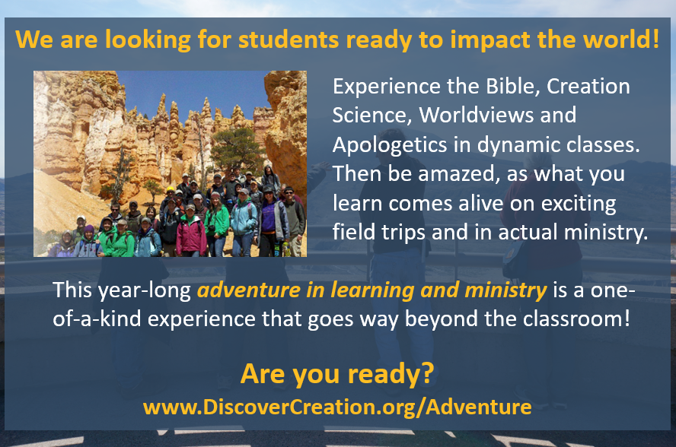
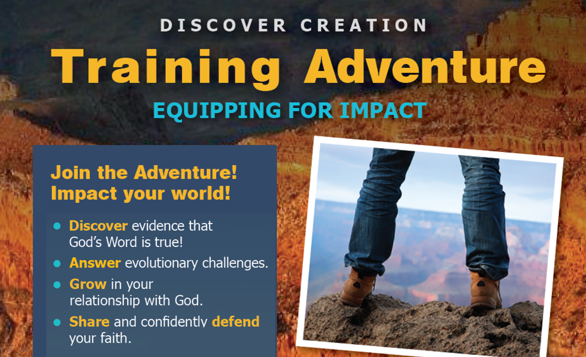
Apply Now! Space is limited for this 1-year Training program!

Name: _________________________________________________________________________ Age: ____________
Hometown: ________________________________________ Phone Number: __________________________________
Email: _____________________________________________________
- What is most exciting to you about the Discover Creation Training Adventure?

- What do you think is the most important thing that is needed in Creation ministry or in our culture in general today? How can you help?

- What is your Passion(s)? What are your Interests?

- What do you hope to have done in the next 3 years? 10 years?

- On a scale of 1-10, (10 being the greatest), how would you score your interest in each of the following?

___ Outdoor Adventure
___ Hiking
___ Skiing
___ Biking
___ Outdoor Education
___ Freedom from Oversight (Parents or otherwise)
___ Creation Science
___ Creation Evangelism
___ Exercise
___ Science Field Studies (Field trips)
___ College Campus Lifestyle
___ Personal Health/Nutrition
___ Community
___ Independence
___ Investing in others
___ Being invested in by others
___ Small Group Interaction
___ Personal Accountability
___ Teaching (either formally or informally)
___ Elementary ages
___ Middle School
___ High School
___ College
___ Adult
___Other: _______________________

Turn in Now or Mail Application to:
Alpha Omega Institute, PO Box 4343 Grand Junction, CO 81502 training@discovercreation.org 970-523-9943

